STEM NOTEBOOK

**Chemical Interactions**

Investigation 2: Elements

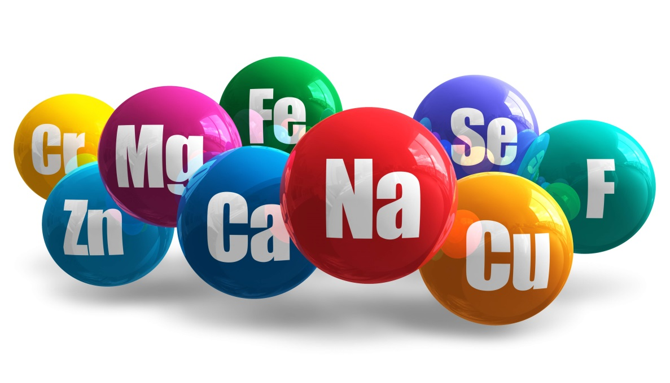

BIG QUESTION: What is an element and what is the importance of elements to our society?

|  |
| --- |
| What Do You See?  (mystery spy) |
| What Do You Think? |
| What Do You Think Now? |

|  |
| --- |
| FOCUS QUESTION: Which elements am I familiar with and what tool is used to organize them? |
| OBSERVATIONS: |
| EXPLANATION: |
| FOCUS QUESTION: How are elements organized by property on the periodic table? |
| OBSERVATIONS:    KEY: |
| EXPLANATIONS: |

|  |
| --- |
| FOCUS QUESTION: How are elements organized by group on the periodic table? |
| OBSERVATIONS:    KEY: |
| EXPLANATIONS: |
| FOCUS QUESTION: In what state of matter do most elements exist? |
| OBSERVATIONS:    KEY: |
| EXPLANATIONS: |

READ: *Elements*

[](http://www.google.com/url?sa=i&rct=j&q=swap&source=images&cd=&cad=rja&docid=OJhLJ4prgzt77M&tbnid=1HNBxnz5cLqY9M:&ved=0CAUQjRw&url=http://www.derivativepricing.com/blog/bid/78048/Interest-Rate-Swap-Tutorial-Part-1-of-5-terminology&ei=564wUqLkAZLd4AOyxoDoCg&bvm=bv.52109249,d.dmg&psig=AFQjCNGxItKVcL3yUwb8uaeE8rMwptvz9Q&ust=1379008602678220)FACT SWAP [](http://www.google.com/url?sa=i&rct=j&q=swap&source=images&cd=&cad=rja&docid=OJhLJ4prgzt77M&tbnid=1HNBxnz5cLqY9M:&ved=0CAUQjRw&url=http://www.derivativepricing.com/blog/bid/78048/Interest-Rate-Swap-Tutorial-Part-1-of-5-terminology&ei=564wUqLkAZLd4AOyxoDoCg&bvm=bv.52109249,d.dmg&psig=AFQjCNGxItKVcL3yUwb8uaeE8rMwptvz9Q&ust=1379008602678220)

My Facts

|  |  |  |
| --- | --- | --- |
|  |  |  |

Facts from my Classmates

|  |  |  |
| --- | --- | --- |
|  |  |  |
|  |  |  |

WORD BANK/CONTENT

_________________________________________________________________________________________________________________________________________________________________________________________________________________________________________________________________________________________________________________________________________________________________________________________________________________________________________________________________________________________________________________________________________________________________________________________________________________________________________________________________________________________________________________________________________________________________________________________________________________________________________________________________

|  |
| --- |
| FOCUS QUESTION: What observations can be made about the elements that make up the substances used in Investigation 1? |
| DATA:   |  |  |  | | --- | --- | --- | | Substance | Chemical Formula | Elements | |  |  |  | |  |  |  | |  |  |  | |  |  |  | |  |  |  | |  |  |  | |
| EXPLANATION: |

|  |
| --- |
| FOCUS QUESTION: Where can elements be found in our everyday world? |
| OBSERVATIONS:  I was surprised that…  I never knew that… |
| PRODUCT SEARCH:   |  |  | | --- | --- | | Product | Elements I recognize/can find | |  |  | |  |  | |  |  | |
| EXPLANATION: |

WORD BANK/CONTENT

_________________________________________________________________________________________________________________________________________________________________________________________________________________________________________________________________________________________________________________________________________________________________________________________________________________________________________________________________________________________________________________________________________________________________________________________________________________________________________________________________________________________________________________________________________________________________________________________________________________________________________________________________

Look at the statements below. Do you agree or disagree with the statement? Place a check in the box.

Read *Elements in the Universe.*

* While you read, or after reading, mark the second box that tells the answer or your belief. You may use any evidence from the reading to support your choice and reasoning.

Before After

|  |  |  |  |  |
| --- | --- | --- | --- | --- |
| **Agree** | **Disagree** | **Statement** | **Agree** | **Disagree** |
|  |  | Everything and everyone is made up of stardust.  **SUPPORT:** |  |  |
|  |  | The sun is not matter; therefore, it is not made of elements.  **SUPPORT:** |  |  |
|  |  | There are 90 naturally occurring elements.  **SUPPORT:** |  |  |
|  |  | The most abundant element on Earth is oxygen.  **SUPPORT:** |  |  |
|  |  | Magnesium and silicon are 2 of the main elements in rocks and minerals.  **SUPPORT:** |  |  |
|  |  | The Earth is a simple place because it only contains a small number of the possible elements.  **SUPPORT:** |  |  |
|  |  | The atmosphere is mostly nitrogen and oxygen, with small quantities of elements added from human factors.  **SUPPORT:** |  |  |
|  |  | The oceans contain only a few elements.  **SUPPORT:** |  |  |
|  |  | All life is based on 21 essential elements.  **SUPPORT:** |  |  |

The human body is about 75% water. Is water an element?

**Response Sheet- Elements**

Carla studied the ingredients on a box of cereal. She made a list of the elements she found. She told her friend,

*“This cereal contains eight different elements. I wonder what the rest of the cereal is made of?”*

If you were Carla’s friend, what would you tell her?

_________________________________________________________________________________________________________________________________________________________________________________________________________________________________________________________________________________________________________________________________________________________________________________________________________________________________________________________

|  |  |
| --- | --- |
| BIG QUESTION: | |
| CLAIM  I claim  I claim  I claim | EVIDENCE  I know this because  I know this because  I know this because |