STEM NOTEBOOK

**Chemical Interactions**

Investigation 3: Particles

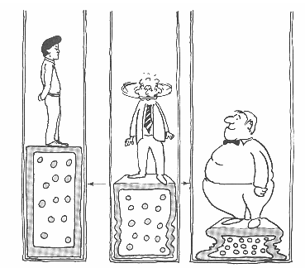

BIG QUESTION: What are the properties of a gas and is gas matter?

|  |
| --- |
| What Do You See? |
| What Do You Think? |
| What Do You Think Now? |

|  |
| --- |
| FOCUS QUESTION: How can I use a strip of paper as a model for understanding elements and particles and how can I enhance that understanding through research? |
| OBSERVATIONS: |
| RESEARCH |
| EXPLANATION: |

|  |
| --- |
| FOCUS QUESTION: How can modeling be used to represent the particles of a gas? |
| OBSERVATIONS: |
| PARTICLE MODEL |
| EXPLANATION: |
| EXTENSION:  *Multimedia* |

WORD BANK/CONTENT

________________________________________________________________________________________________________________________________________________________________________________________________________________________________________________________________________________________________________________________________________________________________________________________________________________________________________________________________________________________________________________________________________________________________________________________________________________________________________________________________________________________________________________________________________________________________________________________________________________What Do You Think Now?

RESPONSE SHEET- Air as Particles

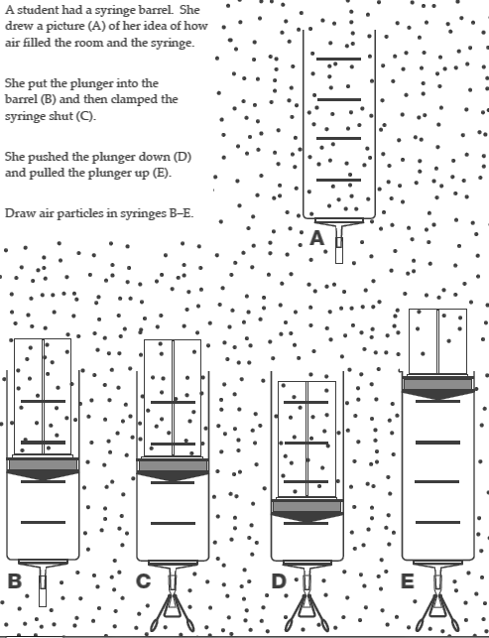

|  |  |
| --- | --- |
| FOCUS QUESTION: Do gases have volume? | |
| OBSERVATIONS | |
| PLAN | DATA  CLASS DATA |
| EXPLANATION | |
| EXTENSION | |

WORD BANK/CONTENT

_________________________________________________________________________________________________________________________________________________________________________________________________________________________________________________________________________________________________________________________________________________________________________________________________________________________________________________________________________________________________________________________________________________________________________________________________________________________________________________________________________________________________________________________________________________________________________________________________________________________________________________________________

|  |  |
| --- | --- |
| FOCUS QUESTION: Do gases have mass? | |
| PREDICTION: | |
| PLAN | DATA |
| EXPLANATION: | |

Look at the statements below. Do you agree or disagree with the statement? Place a check in the box.

Read *Three Phases of Matter.*

* While you read, or after reading, mark the second box that tells the answer or your belief. You may use any evidence from the reading to support your choice and reasoning.

Before After

|  |  |  |  |  |
| --- | --- | --- | --- | --- |
| **Agree** | **Disagree** | **Statement** | **Agree** | **Disagree** |
|  |  | There are 3 phases of matter.  **SUPPORT:** |  |  |
|  |  | One property of solids is that their size and shape do not change.  **SUPPORT:** |  |  |
|  |  | A liquid doesn’t have a shape. The shape depends on where it is.  **SUPPORT:** |  |  |
|  |  | Gases have a definite shape and volume.  **SUPPORT:** |  |  |
|  |  | Particles of a liquid are packed close together but are able to flow past each other. They fill the bottom of their containers.  **SUPPORT:** |  |  |
|  |  | There is no space between gas particles. There is very little particle motion in gases.  **SUPPORT:** |  |  |
|  |  | The force of a syringe would cause the largest change in a sample of a solid.  **SUPPORT:** |  |  |
|  |  | Gases can be compressed.  **SUPPORT:** |  |  |
|  |  | The force that moving particles of a gas place on the plunger eventually makes it difficult to push the plunger further.  **SUPPORT:** |  |  |

WORD BANK/CONTENT

_________________________________________________________________________________________________________________________________________________________________________________________________________________________________________________________________________________________________________________________________________________________________________________________________________________________________________________________________________________________________________________________________________________________________________________________________________________________________________________________________________________________________________________________________________________________________________________________________________________________________________________________________

|  |  |
| --- | --- |
| BIG QUESTION: | |
| CLAIM  I claim  I claim  I claim | EVIDENCE  I know this because  I know this because  I know this because |