STEM NOTEBOOK

**Chemical Interactions**

Investigation 4: Kinetic Energy

[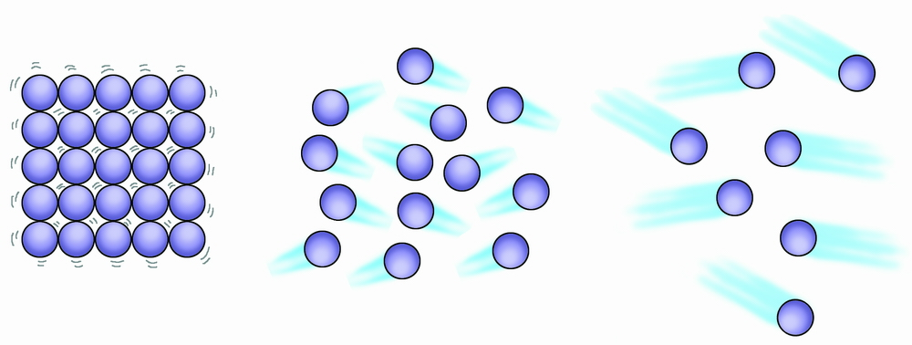](http://ellenmeek.co.uk/?attachment_id=80)

BIG QUESTION: What impact does kinetic energy have on the behavior of matter?

|  |  |
| --- | --- |
| FOCUS QUESTION: What would happen if we heated or cooled air in a bottle? | |
| PLAN (heat) | PLAN (cool) |
| DATA | DATA |
| EXPLANATION: | EXPLANATION: |

WORD BANK/CONTENT

_________________________________________________________________________________________________________________________________________________________________________________________________________________________________________________________________________________________________________________________________________________________________________________________________________________________________________________________________________________________________________________________________________________________________________________________________________________________________________________________________________________________________________________________________________________________________________________________________________________________________________________________________

**T-Chart Compare and Contrast**

|  |  |
| --- | --- |
| Similarities |  |

WORD 2:

WORD 1:

|  |
| --- |
| Differences |

|  |
| --- |
| FOCUS QUESTION: Can a liquid be compressed? |
| OBSERVATIONS |
| EXPLANATION: |

|  |  |
| --- | --- |
| FOCUS QUESTION: What happens when a liquid is heated or cooled? | |
| PREDICTION: | PREDICTION: |
| OBSERVATIONS | OBSERVATIONS |
| EXPLANATION: | EXPLANATION: |

Thermometer 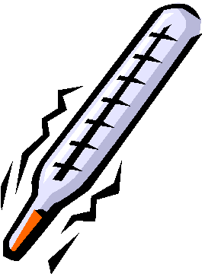

Mr. Martinez placed a thermometer in a jar of very hot water. His students watched what happened to the thermometer. Immediately, the level of the red liquid in the thermometer went up. His students disagreed about why the red liquid in the thermometer rose when the thermometer was placed in hot water. This is what they said:

Jean-Paul: “The hot water pushed it up.”

Pita: “The mass of the red liquid increased.”

Jon: “The heat inside the thermometer rises.”

Jimena: “The air inside the thermometer pulls it up.”

Molly: “The particles of the red liquid are further apart.”

Greta: “The number of particles in the red liquid increased.”

Keanu: “The particles of the red liquid are getting bigger.”

Which student do you most agree with? _____________________________

Explain why you think that student has the best explanation.

_______________________________________________________________________________________________________________________________________________________________________________________________________________________________________________________________________________________________________________________________________________

WORD BANK/CONTENT

_________________________________________________________________________________________________________________________________________________________________________________________________________________________________________________________________________________________________________________________________________________________________________________________________________________________________________________________________________________________________________________________________________________________________________________________________________________________________________________________________________________________________________________________________________________________________________________________________________________________________________________________________

***WINDOW NOTES – Particles in Motion***

|  |  |
| --- | --- |
| **Evaluate / Feelings:**  How well did the plans developed by your team model kinetic energy in gases and liquids?  Where might you have experienced this phenomenon in your everyday life? | **Ideas / Connections / Meaning and Relevance:**  How are the particles in a solid, liquid, and gas the same? How are they different?  Why do tires often alert a “low pressure” reading when the temperature drops? |
| **Remember / Facts:**  What is kinetic energy?  What are two ways to increase an object’s kinetic energy? | **Questions / Understand:**  What happens to a sample of matter when its particles lose kinetic energy?  Explain why a balloon inflates when a bottle-balloon system is placed in hot water. |

WORD BANK/CONTENT

_________________________________________________________________________________________________________________________________________________________________________________________________________________________________________________________________________________________________________________________________________________________________________________________________________________________________________________________________________________________________________________________________________________________________________________________________________________________________________________________________________________________________________________________________________________________________________________________________________________________________________________________________

RESPONSE SHEET- KINETIC ENERGY

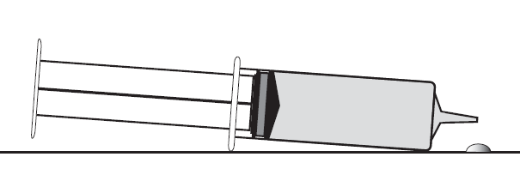

Bess filled a syringe with water and left it by the sink in the sunshine. Ten minutes later, she saw a little puddle of water under the syringe tip. Bess said,

*“This syringe must be broken. It’s leaking.”*

But it wasn’t broken.

What do you think caused the little puddle of water to appear under the syringe tip? *(NOTE: Use the words* ***particles*** *and* **kinetic energy** *in your explanation)*

_____________________________________________________________________________________________________________________________________________________________________________________________________________________________________________________

|  |  |
| --- | --- |
| FOCUS QUESTION: What happens when a solid is heated or cooled? | |
| PREDICTION: (heat) | PREDICTION: (cool) |
| OBSERVATIONS | OBSERVATIONS |
| EXPLANATION: | EXPLANATION: |

Iron Bar 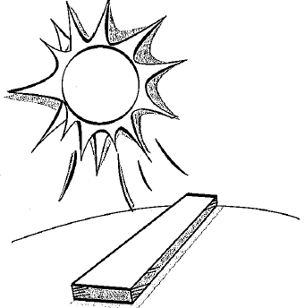

Nate measured an iron bar. He put the iron bar in the hot sun. When he measured the bar after it had been in the sun, it was slightly longer. Which sentence best describes what happened to the iron particles after the bar was left in the hot sun?

A The number of particles increased.

B The size of the particles increased.

C The space between each particle increased.

D The air in the spaces between the iron particles expanded.

E Some of the particles began to melt and spread out further in the bar.

F The heat caused the atoms to flow around the bar and pushed it outward.

Explain your thinking about what happens to particles when a metal is heated. You may draw pictures to support your explanation.

_____________________________________________________________________________________________________________________________________________________________________________________________________________________________________________________________________________________________________________________________________________________________________________________________________________________________________________________________________________________

Read *Expansion/Contraction*

What are expansion joints, and, why are they used?

What causes the cap to pop off a bottle of orange juice that is not replaced in the refrigerator?

WORD BANK/CONTENT

_________________________________________________________________________________________________________________________________________________________________________________________________________________________________________________________________________________________________________________________________________________________________________________________________________________________________________________________________________________________________________________________________________________________________________________________________________________________________________________________________________________________________________________________________________________________________________________________________________________________________________________________________

|  |  |
| --- | --- |
| BIG QUESTION: | |
| CLAIM  I claim  I claim  I claim | EVIDENCE  I know this because  I know this because  I know this because |