STEM NOTEBOOK

*Chemical Interactions*

[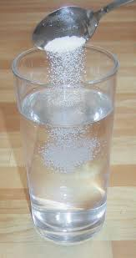](http://www.google.com/url?sa=i&rct=j&q=salt%20solution&source=images&cd=&cad=rja&uact=8&ved=0CAcQjRw&url=http://commons.wikimedia.org/wiki/File:SaltInWaterSolutionLiquid.jpg&ei=u3ZrVPH2DMXbsAT31ICQAQ&psig=AFQjCNFCMKJv-_-9GMk_fC8n4IkcQVTbtA&ust=1416415169007176)

Investigation 8: Solutions

BIG QUESTION: What properties define mixtures and solutions?

|  |  |
| --- | --- |
| FOCUS QUESTION: What observations of mixtures can be made? | |
| ***Observations of: ______________________***   |  |  |  |  | | --- | --- | --- | --- | | ***Think of properties you can see*** *such as size, shape, color, lines, texture, pattern, behavior…* | I observed…   |  | | --- | | NaCl | | CaCO3 | | | ***Think of the other senses*** *of smell, sound, touch, and perhaps taste* | I noticed…   |  | | --- | | NaCl | | CaCO3 | | | *Connect it with something that you already know.* | It reminds me of…   |  | | --- | | NaCl | | CaCO3 | | | *Add more detail to support your statement.* | This is so because…   |  | | --- | | NaCl | | CaCO3 | | | *Be curious and ask questions you could investigate.* | I am curious about…  I wonder what would happen if… | | |
| PREDICTION: | |
| PLAN | DATA |
| EXPLANATION | |

|  |  |
| --- | --- |
| FOCUS QUESTION: Can mixtures be separated? | |
| PLAN | DATA |
| EXPLANATION: | |
| EXTENSION: | |

**FACT SWAP**

*Read: How Things Dissolve*

My Facts

|  |  |  |
| --- | --- | --- |
|  |  |  |

Facts from my Classmates

|  |  |  |
| --- | --- | --- |
|  |  |  |
|  |  |  |

WORD BANK/CONTENT

______________________________________________________________________________________________________________________________________________________________________________________________________________________________________________________________________________________________________________________________________________________________________________________________________________________________________________________________________________________________________________________________________________________________________________________________________________________________________________________________________________________________________________________________________________________________________________________________________________________________________________________________________________________________________

|  |  |
| --- | --- |
| FOCUS QUESTION: What does it mean for a solution to be saturated? | |
| Challenge: | |
| PLAN | DATA |
| EXPLANATION: | |
| EXTENSION: | |

|  |  |
| --- | --- |
| FOCUS QUESTION: Is the amount of substance that will dissolve in water the same for all substances? | |
| Prediction: | |
| PLAN | DATA |
| EXPLANATION: | |
| EXTENSION: | |

WORD BANK/CONTENT

______________________________________________________________________________________________________________________________________________________________________________________________________________________________________________________________________________________________________________________________________________________________________________________________________________________________________________________________________________________________________________________________________________________________________________________________________________________________________________________________________________________________________________________________________________________________________________________________________________________________________________________________________________________________________

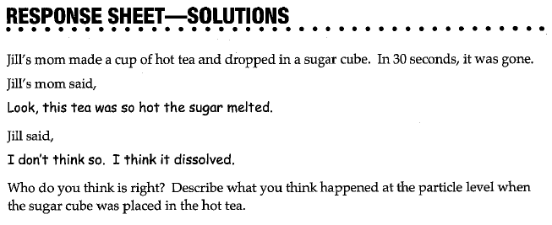

|  |
| --- |
| What Do You See? |
| What Do You Think? |
| What DO You Think Now? |

|  |
| --- |
| FOCUS QUESTION: How can you determine which solutions are more concentrated? |
| PLAN |
| DATA |
| EXPLANATION |
| EXTENSION |

WORD BANK/CONTENT

______________________________________________________________________________________________________________________________________________________________________________________________________________________________________________________________________________________________________________________________________________________________________________________________________________________________________________________________________________________________________________________________________________________________________________________________________________________________________________________________________________________________________________________________________________________________________________________________________________________________________________________________________________________________________

|  |
| --- |
| **SUMMARY GRAPHIC ORGANIZER** |
| *Title: _______________________________________________* |
| Main Idea |
| What are the 3 most important words in the Main Idea, and write them here:  ________________________, _______________________, ________________________ |
| Three Important Details   1. _______________________________________________________________________ 2. _______________________________________________________________________ 3. _______________________________________________________________________ |
| Summary of the Passage in ONE Sentence |

WORD BANK/CONTENT

_____________________________________________________________________________________________________________________________________________________________________________________________________________________________________________________________________________________________________________________________________________________________________________________________________________________________________________________________________________________________________________________________________________________________________________________________________________________________________________________________________________________________________________________________________________________________________________________________________________________________________________________________________________________________________

|  |  |
| --- | --- |
| BIG QUESTION: What properties define mixtures and solutions? | |
| CLAIM:  I claim  I claim  I claim | EVIDENCE:  I know this because  I know this because  I know this because |