Name _____________________________________________________________

**It’s Still Pretty Simple: Kingdom Protista (Protozoan)**

## Cell Structure

Protozoans do have a nucleus and it’s surrounded by a nuclear membrane. They are called ***eukaryotes***, which means “true nucleus.” They also have cell organelles that help the nucleus perform all the life processes.

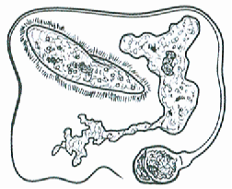

***Number of Cells***

Most Protozoans are single-celled organisms. A few are made up of two or more cells.

## Kinds of Movement

Some Protozoans ***do not*** move at all, but many of them are able to move. Some protists use ***psuedpods***, or false feet. The cell in this type of protists is able to change its shape. It is able to extend some of the cytoplasm to make a fake foot or two. The feet are able to push or pull the cell along.

Other protists move using tiny, hair-like structures called ***cilia***. The cilia are found on the outside of the cell. They are able to move very quickly back and forth, moving the protists along through water or another liquid.

Finally, some protists move using ***flagella***. These are simple, whip-like structures that propel the protist through its environment.

## Nutrition

Some protists are producers and have chloroplasts and chlorophyll. Others are consumers.

***Is it a Protist or Not?***

*Any organism that has these specific characteristics is a Protista. If it doesn’t have these characteristics, it’s not a Protista.*

*Guess what? I have found some new organisms. I think they should be classified as either Moneran or Protist, but I’m not sure. Look at the following characteristics and see if you can decide which kingdom they should be in.*

1. When I look at one of the organisms in the microscope, I notice a tiny nucleus inside the cell. This organism should be classified as a…

a. Moneran c. Could be either

b. Protist

2. When I look at the next organism, I notice it has more than one cell. I don’t see any tissues or organs, but the group of cells seems to be one organism, not a colony; all cells have a nucleus. This organism should be classified as a…

a. Moneran c. Could be either

b. Protist

3. This organism is moving. I notice that it is a single cell, with a flagellum. I cannot tell if this organism has a nucleus or not. This organism should be classified as a…

a. Moneran c. Could be either

b. Protist

4. This is a simple organism with chloroplasts in its cell. It makes its own food. This organism should be classified as a…

a. Moneran c. Could be either

b. Protist

5. This organism is most likely a…

a. Moneran c. Could be either

b. Protist

**The Amoeba**

(modified from The Biology Corner – Worksheets and Lessons)

The ***amoeba*** is a protozoan. It belongs to ***Kingdom* *Protista***. Protists are microscopic one-celled organism. The amoeba is an animal-like protist. It can move and consumes its food (consumer). The amoeba moves by stretching its cytoplasm. These are called ***pseudopods*** ("false foot"). The amoeba can change its shape. Amoebas live in ponds or puddles, and can even live inside people.

The pseudopods help an amoeba to eat. They surround the food and put it in a food vacuole. The food is digested while in the food vacuole.

Amoebas can cause disease. One disease caused by the amoeba is called ***Amoebic* *Dysentery***. A person becomes infected by drinking unsanitary water. The amoeba upsets the person's digestive system and causes cramps and diarrhea.

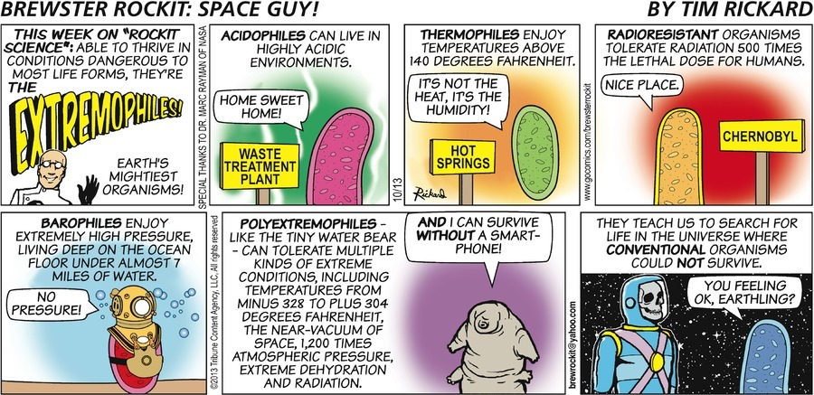

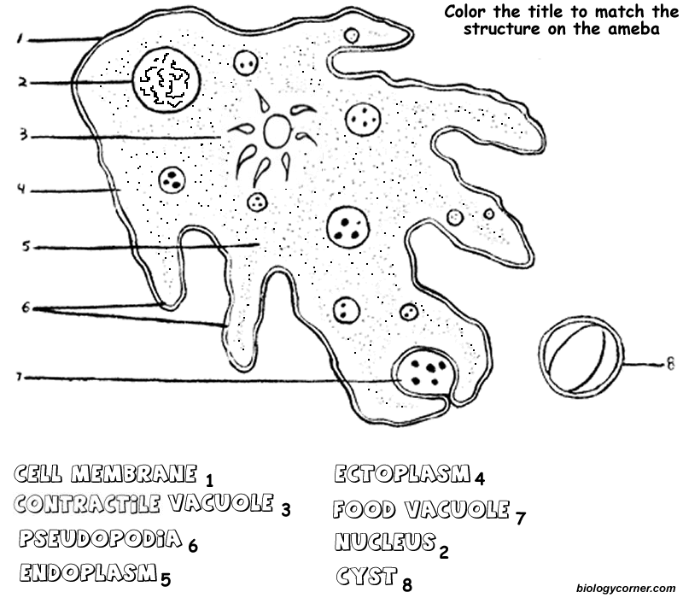 The long finger-like extensions are the pseudopods. When you color them, color only the finger-like extension. The interior of the amoeba is the cytoplasm.

**🞴🞴**

**🞴**

**🞴🞴**

**🞴**

**Cytoplasm**

**🞴**

The endoplasm is the inner part of the amoeba (with the spots); the ectoplasm is the white inside part around the membrane.

**The Amoeba**

6. How does an amoeba move?

a. Cilia c. Pseudopods

b. Flagellum

7. What disease is caused by the amoeba?

a. Athlete’s Foot c. Botulism

b. Amoebic Dysentery d. Strep Throat

8. To what Kingdom does the amoeba belong?

a. Monera c. Plant

b. Animal d. Protist

**The Euglena**

(modified from The Biology Corner – Worksheets and Lessons)

Euglena is one-celled (unicellular) organisms. They belong to Kingdom Protista. All Euglena have chloroplasts. Chloroplast allows Euglena to make their own food (they are producers). Euglena can also absorb food from their environment. Euglena lives in ponds or puddles.

Euglena move by a flagellum (plural ‚ flagella), which is a long whip-like structure that acts like a little motor. The flagellum is located on the front end, and twirls in such a way as to pull the cell through the water. ***Color the reservoir light blue and the flagellum black*.**

Chloroplasts use sunlight to make the Euglena’s food. They are rod-like structures throughout the cell. ***Color the chloroplasts green***. Euglena has an eyespot at the front end. It detects light. This helps the Euglena find bright areas to gather sunlight to make their food. ***Color the eyespot red*.**

The Euglena has a stiff pellicle outside the cell membrane. It helps it keep its shape. The Euglena can also move like an inchworm. ***Color the pellicle blue***.

In the center of the cell is the nucleus. It controls the cell’s activities. The nucleolus can be seen within the nucleus. ***Color the nucleus purple***,and ***the nucleolus brown*.**

The interior of the cell contains a jelly-like fluid called cytoplasm**. *Color the cytoplasm yellow***. Toward the back of the cell is a star-like structure. This is the contractile vacuole. It helps remove excess water. If it got too much water, the cell would explode. ***Color the contractile vacuole orange***.



Eyespot

Nucleolus

Chloroplast

Nucleus

Cytoplasm

Pellicle

Contractile Vacuole

Reservoir

Flagellum

**The Euglena**

9. Are Euglena unicellular or multicellular?

a. Multicellular b. Unicellular

10. To what Kingdom do Euglena belong?

a. Monera c. Plant

b. Animal d. Protist

11. What organelle carries out photosynthesis?

a. Chloroplast c. Nucleus

b. Contractile Vacuole d. Nucleolus

12. On which end is the flagellum located?

a. Back b. Front

13. The eyespot is used to detect light.

a. True b. False

14. What is the function of the nucleus?

a. Detect light c. Control the Euglena

b. Make proteins d. Expel excess water.

15. What would happen if the cell did not have the contractile vacuole?

a. It would starve. c. It could not see.

b. It would explode. d. It could not move.

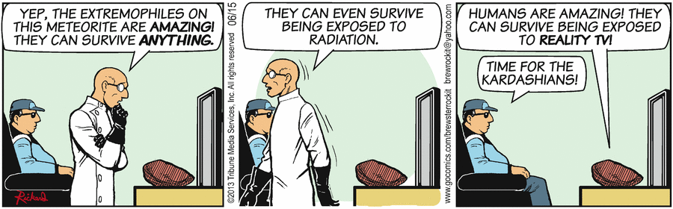

**The Paramecium**

*(modified from The Biology Corner – Worksheets and Lessons)*

Paramecium is one-celled (unicellular) protozoans. They belong to Kingdom Protista. They live in quiet or stagnant ponds. They eat algal scum and other microorganisms. Small organisms eat them. They move by tiny hair-like projections called cilia. ***Color all cilia black***.

The paramecium cannot change its shape. This is because it has a thick outer membrane called the pellicle. ***Color the pellicle light blue***.

There are two types of nuclei (plural of nucleus). The large nucleus is called the macronucleus. It controls respiration, protein synthesis and digestion. ***Color the macronucleus red***. The much smaller micronucleus is used only during reproduction, ***color the micronucleus yellow****.*

Contractile vacuoles are used in animal cells to remove the excess water. The contractile vacuole is shaped like a star - ***color the contractile vacuole green*.**

Paramecium is consumers. Food enters the paramecium through the ***mouth pore (color orange)*** and goes to the ***gullet (color blue)****.* At the end of the gullet, food vacuoles are formed. Food vacuoles remain in the cytoplasm until the food is digested. ***Color all food vacuoles brown***. Undigested food particles are eliminated through *the* ***anal pore (color light green)****.* The indented area where food enters the paramecium is referred to as the oral groove.

Just inside the pellicle are trichocysts. The paramecium can shoot tiny threads out of the cell to entangle a predator or to make themselves appear bigger. ***Color the trichocysts purple****.*

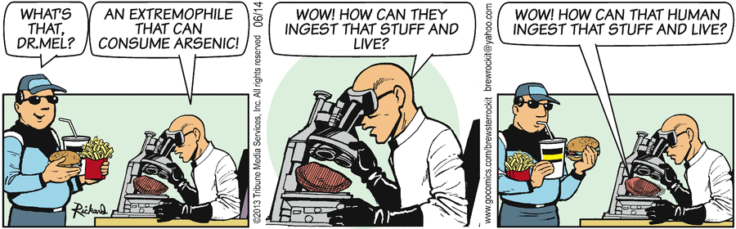

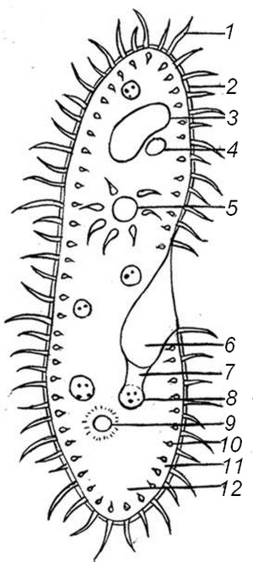

|  |  |
| --- | --- |
| ***Key to Diagram*** | |
| 1. Cilia  2. Pellicle  3. Macronucleus  4. Micronucleus  5. Contractile Vacuole  6. Mouth Pore | 7. Gullet  8. Food Vacuole  9. Anal Pore  10. Trichocysts  11. Ectoplasm  12. Endoplasm |

**The Paramecium**

16. Is the paramecium a unicellular or multicellular organism?

a. Multicellular b. Unicellular

17. What do paramecium eat?

a. Algal scum c. Small fish

b. Other microbes d. Both a & b

18. What is the function of the contractile vacuole?

a. Detect light c. Control the Euglena

b. Make proteins d. Get rid of excess water.

19. Where do paramecium live?

a. Rivers c. Ocean

b. Stagnant ponds d. Ditches

**Answer Key**

**It’s Still Pretty Simple: Kingdom Protista (Protozoan) - Key**

1. When I look at one of the organisms in the microscope, I notice a tiny nucleus inside the cell. This organism should be classified as a…

***b. Protist***

2. When I look at the next organism, I notice it has more than one cell. I don’t see any tissues or organs, but the group of cells seems to be one organism, not a colony; all cells have a nucleus. This organism should be classified as a…

***b. Protist***

3. This organism is moving. I notice that it is a single cell, with a flagellum. I cannot tell if this organism has a nucleus or not. This organism should be classified as a…

***c. Could be either***

4. This is a simple organism with chloroplasts in its cell. It makes its own food. This organism should be classified as a…

***c. Could be either***

5. This organism is most likely a…

***b. Protist***

**The Amoeba**

6. How does an amoeba move?

***c. Pseudopods***

7. What disease is caused by the amoeba?

***b. Amoebic Dysentery***

8. To what Kingdom does the amoeba belong?

***d. Protist***

**The Euglena**

9. Are Euglena unicellular or multicellular?

***b. Unicellular***

10. To what Kingdom do Euglena belong?

***d. Protist***

11. What organelle carries out photosynthesis?

***a. Chloroplast***

12. On which end is the flagellum located?

***b. Front***

13. The eyespot is used to detect light.

***a. True***

14. What is the function of the nucleus?

***c. Control the Euglena***

15. What would happen if the cell did not have the contractile vacuole?

***b. It would explode.***

**The Paramecium**

16. Is the paramecium a unicellular or multicellular organism?

***b. Unicellular***

17. What do paramecium eat?

***d. Both a & b***

18. What is the function of the contractile vacuole?

***d. Get rid of excess water.***

19. Where do paramecium live?

***b. Stagnant ponds***

**Scoring Guide**

|  |  |
| --- | --- |
| ***1. b (3 choices)***  ***2. b (3 choices)***  ***3. c (3 choices)***  ***4. c (3 choices)***  ***5. b (3 choices)***  ***6. c (3 choices)***  ***7. b***  ***8. d***  ***9. b (2 choices)***  ***10. d***  ***11. a***  ***12. b (2 choices)***  ***13. a (2 choices)***  ***14. c***  ***15. b***  ***16. a***  ***17. d***  ***18. d***  ***19. b*** | ***Scoring Guide***  ***14-19 – 3***  ***7-13 – 2***  ***1-6 – 1***  ***0 – 0*** |