STEM NOTEBOOK

*Earth’s Resources*

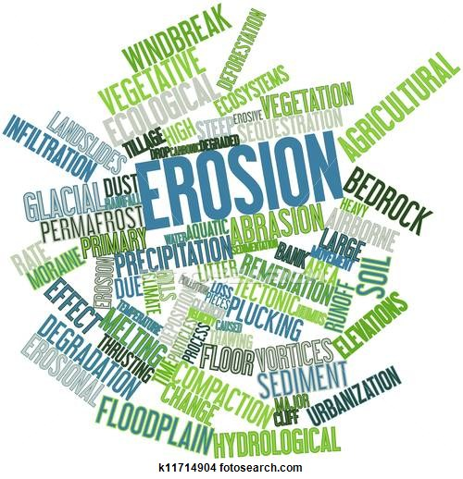

Investigation 3: Weathering and Erosion

BIG QUESTION: What factors must be considered when designing an outdoor basketball court?

|  |
| --- |
| What Do You See? |
| What Do You Think? |
| What Do You Think Now? |

**ENGINEERING CHALLENGE**

**Scenario:** Imagine that your school sits on top of a hill. There is no room for a basketball court. One of the parents is willing to donate some land at the bottom of the hill for the school to use as a basketball court. Everyone is excited about the idea until the school board meeting. “Wait a minute…If we build a basketball court at the bottom of the hill, how are we going to prevent erosion? What is the point in a court if it is always covered by dirt and mud all the time?” The school board decides not to accept the donation and you and your friends are very disappointed. After talking with your science teacher, you decide to approach the school board to reconsider. (GOAL)

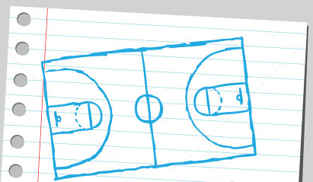

**What do you want to know before you begin?**

Union School District

27 Courthouse Square

Springfield, IL 62700

Dear Science Class:

We are so delighted that your class has taken on the challenge of studying erosion and the impact on the proposed basketball court. We will expect your report within two weeks describing the factors that impact weathering and erosion of soil and rocks. We would also like to hear your recommendations for erosion control on the hill above the court.

The land in question is an empty lot at the foot of a hill. There are houses on both sides of the site. You will have to make sure that none of your erosion-control measures affect these houses. We look forward to you presenting your recommendations to the school board at our next meeting.

Please use the information we have included to help you understand the requirements. Remember, you will have to be careful not to cause any damage to the properties on either side of the court.

**The Proposed Basketball Court**

Dimensions of court 28m X 15m

Vertical height of hill 10m

Required distance from base of hill to court 5m

Distance to houses on either side 12m

Size of houses 30m X 10m

The school board is grateful that you are able to take on this project. Good luck, and let us know if you need more information.

Sincerely,

**Mary Chalmers**

Mary Chalmers

Superintendent

|  |
| --- |
| FOCUS QUESTION: What is mechanical weathering? |
| OBSERVATIONS   |  |  |  | | --- | --- | --- | | Time Lapsed (min) | Mass of Marble Chips (g) | Observations | |  |  |  | |  |  |  | |  |  |  | |  |  |  | |  |  |  | |
| EXPLANATION |
| EXTENSION |
| FOCUS QUESTION: How does the hardness of a rock or mineral impact how easily it is weathered? |
| PREDICTION |
| PLAN |
| DATA |
| EXPLANATION |

|  |
| --- |
| FOCUS QUESTION: What is chemical weathering and how can it be identified? |
| OBSERVATIONS |
| EXPLANATION |
| **SUMMARY GRAPHIC ORGANIZER** |
| *Title: _______________________________________________* |
| Main Idea |
| What are the 3 most important words in the Main Idea, and write them here:  ________________________, _______________________, ________________________ |
| Three Important Details   1. _______________________________________________________________________ 2. _______________________________________________________________________ 3. _______________________________________________________________________ |
| Summary of the Passage in ONE Sentence |

EROSION CASE STUDY

<https://sites.google.com/a/apps.hopkinsschools.org/erosion-case-studies-wjh/home/ocean-rock-and-roll>

|  |  |
| --- | --- |
| CASE NAME | |
| CASE INFORMATION: Time, Location | |
| The Situation | |
| The setup: What was happening before the erosion? What kinds of things was the land being used for? | The problem: What erosion happened, and what problems, if any, did the erosion cause? |
| The Erosion | |
| Causes: What caused the erosion? | Time: How long did it take for the erosion to happen? |
| Solutions | |
| Fixes: How did they try to fix it? Who tried to fix it? | Outcomes: What, if anything, happened as a result? |
| Conclusions: What can we learn from this case? | |
| About causes of erosion? | Anything else? |

WORD BANK: _____________________________________________________________________________________________________________________________________________________________________________________________________________________________________________________________________________________________________________________________________________________________________________________________________________________________________________________________________________________

CONTENT: ________________________________________________________________________________________________________________________________________________________________________________________________________________________________________________________________________________________________________________________________________________________________________________________________________________________________________________________________________________

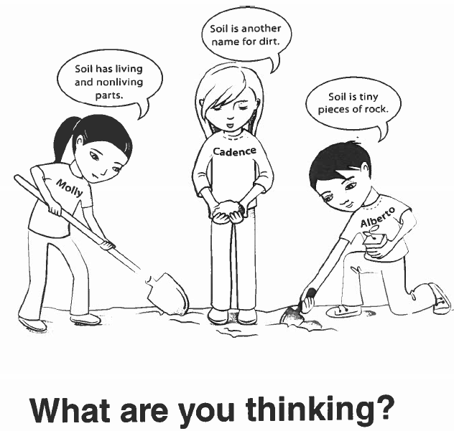

**______________________________________________________LOL**

|  |
| --- |
| FOCUS QUESTION: What are the properties of soil and how do soil samples differ? |
| OBSERVATIONS   |  |  |  |  |  | | --- | --- | --- | --- | --- | | Sample # | Description of Soil Structure | Odor/ Organic Matter | Readily Absorbs Water | Sample Type | |  |  |  |  |  | |  |  |  |  |  | |  |  |  |  |  | |  |  |  |  |  | |  |  |  |  |  | |  |  |  |  |  | |
| EXPLANATION |
| FOCUS QUESTION: What is a soil horizon and what does it tell us about the properties of a soil sample? |
| OBSERVATIONS |
| EXPLANATION |

**FACT SWAP**

*Read: Soils (pg 247)*

My Facts

|  |  |  |
| --- | --- | --- |
|  |  |  |

Facts from my Classmates

|  |  |  |
| --- | --- | --- |
|  |  |  |
|  |  |  |

WORD BANK: _____________________________________________________________________________________________________________________________________________________________________________________________________________________________________________________________________________________________________________________________________________________________________________________________________________________________________________________________________________________

CONTENT: ________________________________________________________________________________________________________________________________________________________________________________________________________________________________________________________________________________________________________________________________________________________________________________________________________________________________________________________________________________

|  |
| --- |
| What Do You See? |
| What Do You Think? |
| What Do You Think Now? |

|  |
| --- |
| FOCUS QUESTION: What do fossils tell us about the history of the Earth? |
| OBSERVATIONS |
| EXPLANATION |

WORD BANK: _____________________________________________________________________________________________________________________________________________________________________________________________________________________________________________________________________________________________________________________________________________________________________________________________________________________________________________________________________________________

CONTENT: ______________________________________________________________________________________________________________________________________________________________________________________________________________________________________________________________________________________________________________________________________________________________________________________________________________________

__________________________________________________________

|  |  |
| --- | --- |
| BIG QUESTION: What factors must be considered when designing an outdoor basketball court? | |
| CLAIM STATEMENTS: | SUPPORTING EVIDENCE: |