STEM NOTEBOOK
Chemical Interactions

Investigation 5/7: Energy Transfer and Phase Change

BIG QUESTION: How does energy transfer and particle kinetic energy induce substances to change from one phase to another?
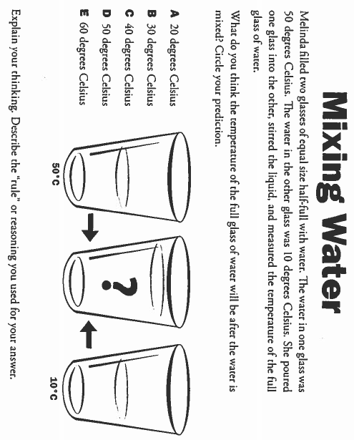

FOCUS QUESTION: How does energy transfer when water is mixed?
PLAN | DATA
EXPLANATION

EXTENSION

FACT SWAP
Read: Energy on the Move (pg 32)
My Facts

Facts from my Classmates

WORD BANK/CONTENT
______________________________________________________________________________________________________________________________________________________________________________________________________________________________________________________________________________________________________________________________________________________________________________________________________________________________________________________________________________________________________________________________________________________________________________________________________________________________________________________________________________________________________________________________________________________________________________________________________________________________________________________________________________________________________

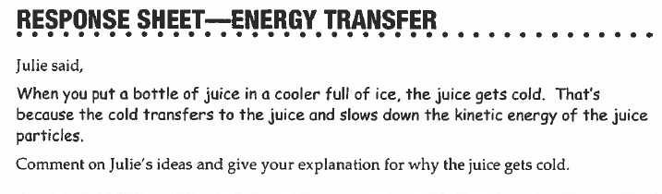

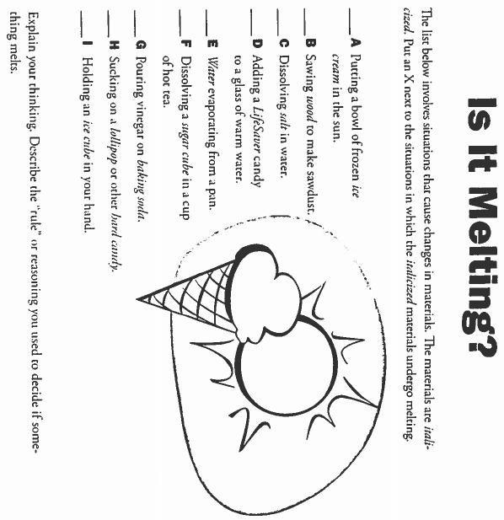

FOCUS QUESTION: What is the difference between dissolving and melting?
PLAN
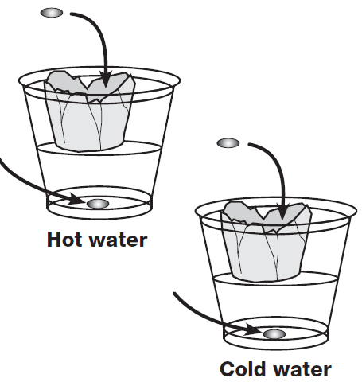

OBSERVATIONS
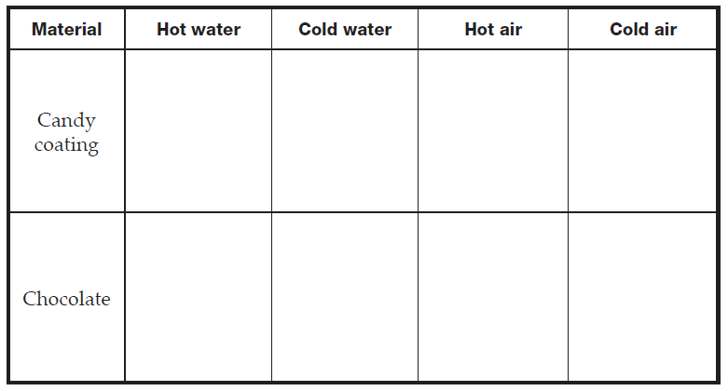
EXPLANATION

WORD BANK/CONTENT
______________________________________________________________________________________________________________________________________________________________________________________________________________________________________________________________________________________________________________________________________________________________________________________________________________________________________________________________________________________________________________________________________________________________________________________________________________________________________________________________________________________________________________________________________________________________________________________________________________________________________________________________________________________________________
FOCUS QUESTION: How does energy transfer cause a material to melt?
PLAN | DATA
EXPLANATION

EXTENSION

WORD BANK/CONTENT
______________________________________________________________________________________________________________________________________________________________________________________________________________________________________________________________________________________________________________________________________________________________________________________________________________________________________________________________________________________________________________________________________________________________________________________________________________________________________________________________________________________________________________________________________________________________________________________________________________________________________________________________________________________________________

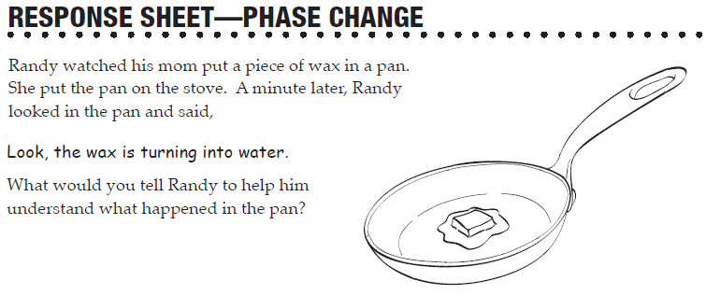
FOCUS QUESTION: How does energy transfer impact freezing?
PLAN

OBSERVATIONS
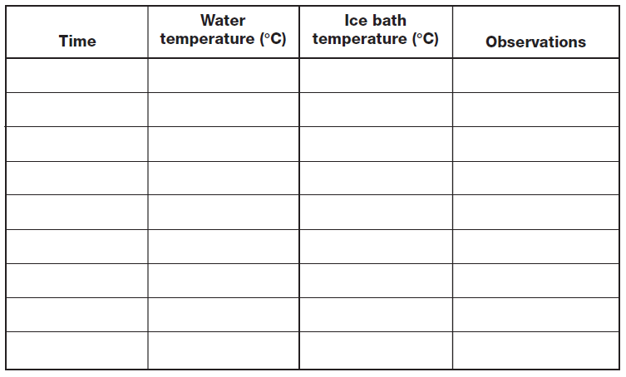

EXPLANATION

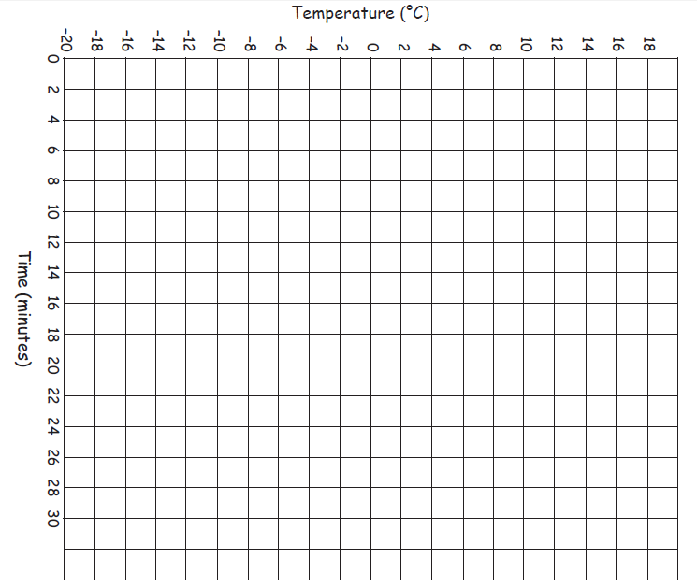
WORD BANK/CONTENT
______________________________________________________________________________________________________________________________________________________________________________________________________________________________________________________________________________________________________________________________________________________________________________________________________________________________________________________________________________________________________________________________________________________________________________________________________________________________________________________________________________________________________________________________________________________________________________________________________________________________________________________________________________________________________
WHAT DO YOU SEE?

WHAT DO YOU THINK?

WHAT DO YOU THINK NOW?

FOCUS QUESTION: How can energy transfer be used to explain condensation and evaporation?
PLAN
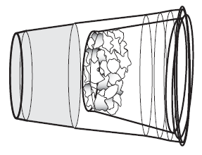

OBSERVATIONS

EXPLANATION

EXTENSION

FACT SWAP
Read: Rock Solid (pg 42)
My Facts

Facts from my Classmates

WORD BANK/CONTENT
_____________________________________________________________________________________________________________________________________________________________________________________________________________________________________________________________________________________________________________________________________________________________________________________________________________________________________________________________________________________
________________________________________________________________________________________________________________________________________________________________________________________________________________________________________________________________________________________________________________________________________________________________________________________________________________________________________________________________________________
__________________________________________________________
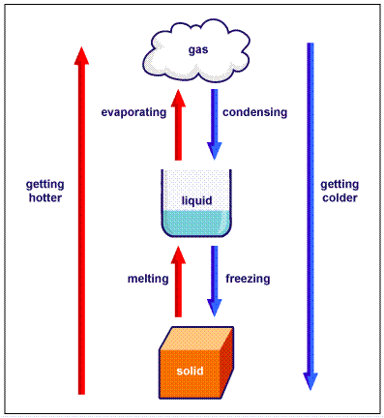

Describe what is happening at a particle level as you move from solid to liquid, and then liquid to gas.

BIG QUESTION:

CLAIM:  I claim  I claim  I claim | EVIDENCE:  I know this because  I know this because  I know this because

