VIRUSES AND THE CYCLE OF REPLICATION
Name _____________________

Directions:

Read the passage below and answer all questions that follow.

Viruses cause damage when the viruses replicate inside the cells. The entry of the virus into the cell is not by itself harmful, but after the virus has replicated itself several hundred times and breaks out, the cell is destroyed. Organ damage in an organism can be severe if enough tissue is damaged by the virus. Any agent that causes disease is called a pathogen.

They cycle of viral infection, replication, and cell destruction is called the lytic cycle. After the viral genes have entered the cell, they use the host cell to replicate viral genes and to make viral proteins, such as capsids. The proteins are then assembled with the replicated viral genes to form complete viruses. The host cell is broken open and releases newly made viruses.

During an infection, some viruses stay inside the cells but do not make new viruses. Instead of producing virus particles, the viral gene is inserted into the host chromosome, and is called a provirus. Whenever the cell divides, the provirus also divides, resulting in two infected host cells. In this cycle, called the lysogenic cycle, the viral genome replicates without destroying the host cell.

- How do viruses damage the cell?_____________________________________________________

__________________________________________________________________________________

- What relationship exists between viruses and pathogens? _________________________________

__________________________________________________________________________________

- What sentence expresses main idea of the second paragraph? _____________________________

- The figure below shows the lytic and lysogenic cycles. In the spaces provided, describe what is occurring in each numbered part of the figure.
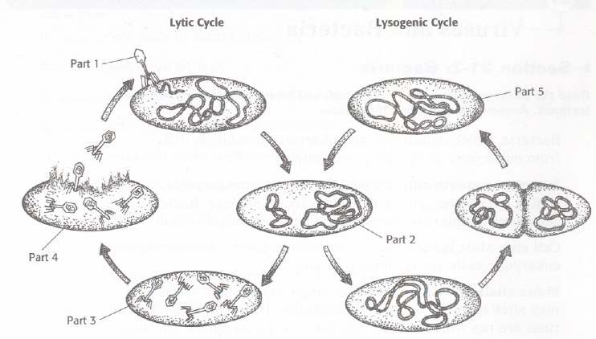
Part 1

Part 2

Part 3

Part 4

Part 5

Circle the letter of the phrase that best completes the statement.

Virus cause damage when they

- invade cells
- replicate inside cells.
- remain inside a host cell.
- Both (a) and (b).

Directions:

First read your textbook pages_____ through_______. Then answer all questions that follow.

- What properties of life does a virus lack?

- How did scientist studying the tobacco mosaic disease know that the infectious agent must be smaller than a bacterium?

- What property of the infectious agent showed that it was a chemical?

