Name ________________________

Top Ten Killer Questions

A. In the first blank, rank which of the following diseases are the worse killers
(1=largest number of deaths / 10=smallest number of deaths)

B. Define homeostasis.

C. Define Disease.

D. Record the correct ranking in the second column.

a. |  | Measles (Morbillivirus – fever, cough, rash caused by virus
b. |  | Cholera (Vibrio Cholerae) – diarrhea, fever caused by bacteria in food and water
c. |  | Flu (Haemophilus Influenza) – Headache, fever, inflamed mucous membranes caused by virus.
d. |  | Tuberculosis (Mycobacteriuim Tuberculosis) – long term infection of respiratory system caused by bacteria.
e. |  | Tetanus (Clostridium Tetani) – convulsions, spasms of jaw and then body, pain caused by bacteria.
f. |  | Hepatitis B Virus – transmitted by body fluids/shared needles; can cause liver cancer, cirrhosis.
g. |  | Hemorrhagic Fever or Dengue Fever (Flavirus) – joint & muscle pain red coloration covers body caused by microorganisms in tropical mosquitoes.
h. |  | Malaria (Plasmodium Falciparium) – chills, fever, sweating with relapses by microorganisms in tropical mosquitoes
i. |  | AIDS (Human Immunodeficiency Virus) – attack of immune system which allows other infections to cause death. Transmitted by infected body fluids.
j. |  | Whooping Cough (Bortadella Pertussis) – cough with whoop at the end of it with increased mucous discharge and pneumonia caused by bacteria.

#1 Haemophilus influenzae and other bacteria (acute lower respiratory infections). Caused 3.7 million deaths from pneumonia and other lung infections. . Airborne transmission. Major killer of children in developing countries. Increasing in incidence because of poverty-related risk factors, such as malnutrition. Treatable with antibiotics. | 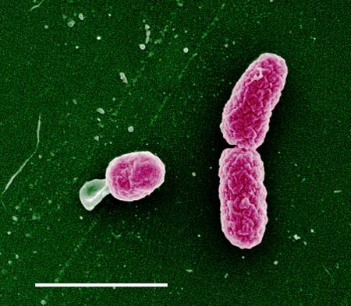
#2 Mycobacterium tuberculosis (tuberculosis). Caused 2.9 million deaths. Bacterium is airborne in respiratory droplets. Ninety-five percent of victims live in developing countries. Treatable with antibiotics, but multidrug-resistant strains have emerged. Vaccine available. | 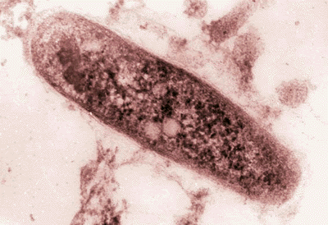  The Top 10 Infectious Killers
#3 Vibrio cholerae and other pathogens (diarrheal diseases). Caused 2.5 million deaths from cholera and other diarrheal diseases. Contaminated water and foods are primary vectors. Most victims are under five years of age and live in developing countries. Death preventable with oral rehydration therapy, proper nutrition, and antibiotics. | 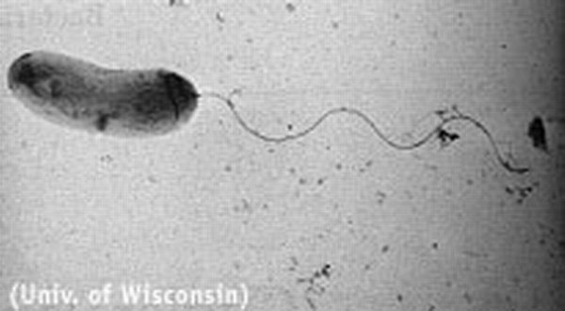
#4 Human immunodeficiency virus (AIDS). Caused 2.3 million deaths. Sub-Saharan Africa thought to have two-thirds of the world's cases. Transmissible through contact with infected body fluids, such as blood and semen. More than 30 million people now infected. No cure or vaccine, but a combination of drugs can prolong life. | 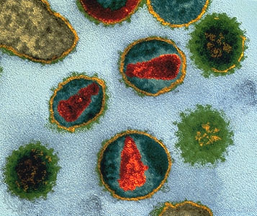
#5 Plasmodium falciparum and related protozoans (malaria). Caused 1.5-2.7 million deaths. Transmitted by infected female Anopheles mosquitoes. Endemic in 100 countries; highest incidence in sub-Saharan Africa. Strikes up to 500 million people per year. Prevention includes eradicating mosquitoes. Curable with early diagnosis and prompt treatment, but protozoa may evolve resistance to drugs. | 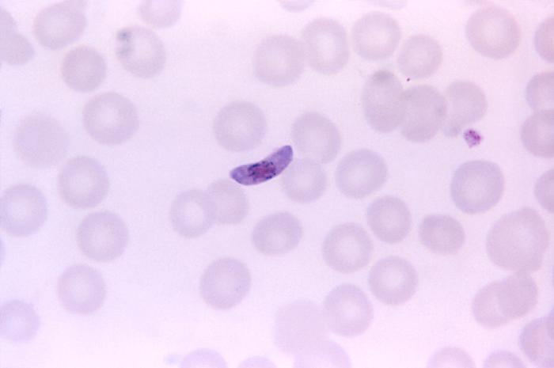
#6 Morbillivirus (measles). Caused 960,000 deaths. Victims primarily children; highest incidence in Africa. Deaths usually due to complications such as pneumonia and encephalitis. Airborne in droplets from nose and mouth. Preventable with vaccine. | 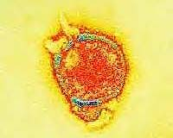
#7 Hepatitis B virus (hepatitis B). Caused 605,000 deaths. Transmitted by blood and other body fluids and through sharing unsterilized needles. Endemic in Africa, South America, Eastern Europe, the eastern Mediterranean, Southeast Asia, China, and the smaller Pacific islands. Victims with acute form usually recover; chronic carriers risk active hepatitis, cirrhosis, and primary liver cancer. Vaccine available. | 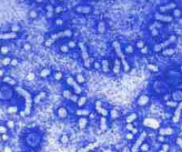
#8 Bortadella pertussis (whooping cough). Caused 410,000 deaths. Bacteria airborne in respiratory droplets. About one-half of cases occur in children under age two. Endemic worldwide. Vaccine available for infants but not adults. Treatable with erythromycin. | 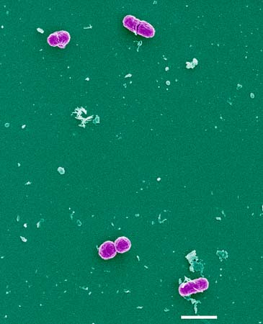
#9 Clostridium tetani (tetanus). Caused 275,000 deaths. Main victims are babies with infected umbilici. Bangladesh, China, India, Indonesia, Nigeria, and Pakistan account for 75 percent of deaths. Preventable by sterile practices and immunization. Spores are ubiquitous, especially in animal waste. | 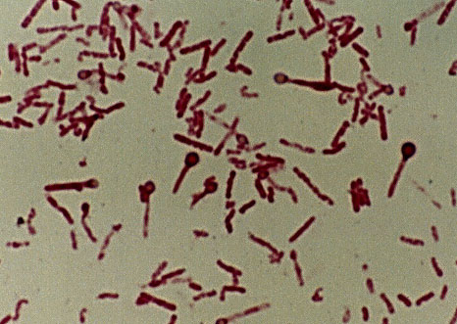
#10 Flavirus (dengue/dengue hemorrhagic fever). Caused 140,000 deaths. Virus is transmitted by Aedes mosquitoes. With increasing urbanization, dengue epidemics are becoming more common--especially in Southeast Asia and Latin America. The hemorrhagic form of the disease is responsible for fatalities, mostly in children under ten. | 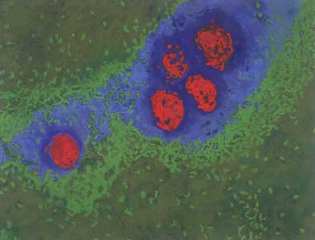
COPYRIGHT 1999 American Museum of Natural History COPYRIGHT 2000 Gale Group

Top Ten Killers

After reading the various segments about the worse killers, please answer the following questions. Note these figures have varied very little in subsequent years through today.

A. Which killer did you underestimate? Overestimate?

B. Determine a percentage of the treatable (curable) diseases. (% = # / total)

C. What killers are caused by risky behavior?

D. List external conditions that people have to face that may cause these diseases.

E. After defining malnourished and undernourished by either common sense, knowledge of Spanish, or dictionary, describe the difference.

F. Why don’t these diseases happen in the United States?

G. Do you feel it is our responsibility to provide help ($, medical, other support) to countries struggling with these conditions? Why or why not?

