Plant Cell Coloring
Directions: Define each of the parts of the plant cell and then label and color the cell parts on the drawing of the plant cell.
Cell Membrane (black) -
Cell Wall (light green) -
Cytoplasm (yellow) -
Chloroplasts (dark Green) -
Golgi Apparatus (light blue) -
Mitochondria (red) -
Microtubules (brown) -
Nucleoplasm (gray) -
Nuclear Membrane (black) -
Nucleolus (tan) -
Ribosomes (orange) -
Rough Endoplasmic Reticulum (dark blue) -
Smooth Endoplasmic Reticulum (violet) -
Vacuole (pink) -

PLANT CELL
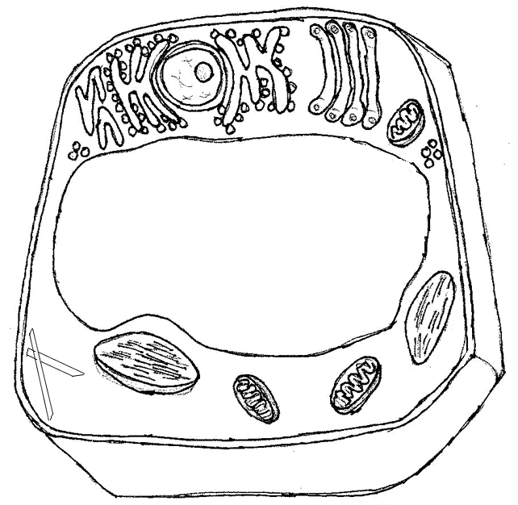
Compare and Contrast the animal cell to the plant cell.

