Rock Cycle Worksheet Name
Use your book and your rock labs.

1.A series of processes that slowly change rocks from one kind to another is referred to as the
________________________.

2. Is the following sentence true or false? The rock cycle is produced by forces inside the Earth and at the surface

Fill in Sedimentary, Igneous or Metamorphic in each box.
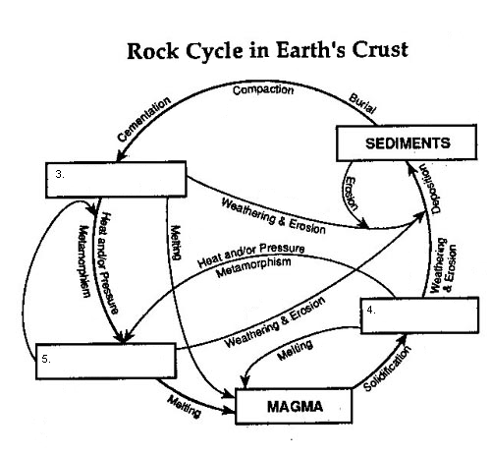

6. All rocks follow the same pathway through the rock cycle is a false statement. Why?

7. How does granite change into sandstone?

8. How does sandstone change into quartzite?

9. Define igneous rocks.
.
10. Give examples of 2 intrusive rocks.

11. Give examples of 2 extrusive rocks.

12. Give examples of 2 rocks that are high in silica.

13. Give examples of 2 rocks that are low in silica.

14. Define sedimentary rock.
.
15. How are clastic rocks formed?
.
16. Give an example of a large grain clastic rock.

17. Give an example of a med. Grain clastic rock.

18. Give an example of a small grain clastic rock.

19. How are chemical sedimentary rocks formed?

20. Give 2 examples of chemical rocks.

21. How are organic sedimentary rocks formed?

22. Give 2 examples of organic rocks.

23. Define Metamorphic rock.

.
24. What does foliated mean?

.
25. Give an example of a foliated rock.

Rock can follow many different pathways through the rock cycle. Here are two examples:
Pathway 1
Between New Zealand and South America, at the bottom of the Pacific Ocean, Molten material from the mantle rises through the crust. As the material comes into contact with the very cold ocean water, it cools quickly to become rock. Over time this rock ever so slowly moves across the ocean floor. About 200 million years later, the rock is pushed downwards. As the rock moves downward, it experiences great amounts of heat and pressure.

Pathway 2
Deep underground, a new rock forms as heat and pressure change its crystals and cause its grains to become foliated. Over millions of years, this rock is uplifted to become part of a mountain. Then, layers of rock above the foliated rock wear away, until it becomes exposed at the surface. Destructive forces wear it down, and its fragments are carried away by a river’s swift-flowing water. Eventually, these fragments flow into the ocean. Ocean water carries the rock fragments away from the river and they are deposited on a beach. Over time, more and more sediment is deposited there, until the fragments that came from the foliated rock become cemented into a new rock. Then more and more rock forms above this rock, until the heat and pressure change its crystals and cause its grains to become foliated.
- Which major group or groups of rocks are involved in the description of Pathway 1?

- Make a flowchart that describes what occurs in pathway 1

- Which major group or groups of rocks are involved in the description of pathway 2?

- Make a flowchart that describes what occurs in Pathway 2.

- Write a description of another pathway through the rock cycle. In your description, tell how igneous rock changes to metamorphic rock, which then changes to sedimentary rock.

31. How are igneous rocks formed?

32. How are sedimentary rocks formed?

33. How are metamorphic rocks formed?

34 Where are intrusive igneous rocks formed? What size of crystals will they have?

35 Where are extrusive igneous rocks formed? What size of crystals will they have?

36 What are clastic rocks?

.
37. What are foliations in metamorphic rocks?

38 How do chemical sedimentary rocks form?

39. How do organic sedimentary rocks form?

40 Why would you tend to find lots of fossils in sedimentary rocks? Why not in other rocks?

41. Why would a metamorphic rock show signs of great stress?

42. List and explain the 6 characteristics of minerals that can be used for identifying minerals in a lab setting:

43. What hardness do the following objects have?

fingernail glass copper penny steel file/nail

