Name ______________________________________
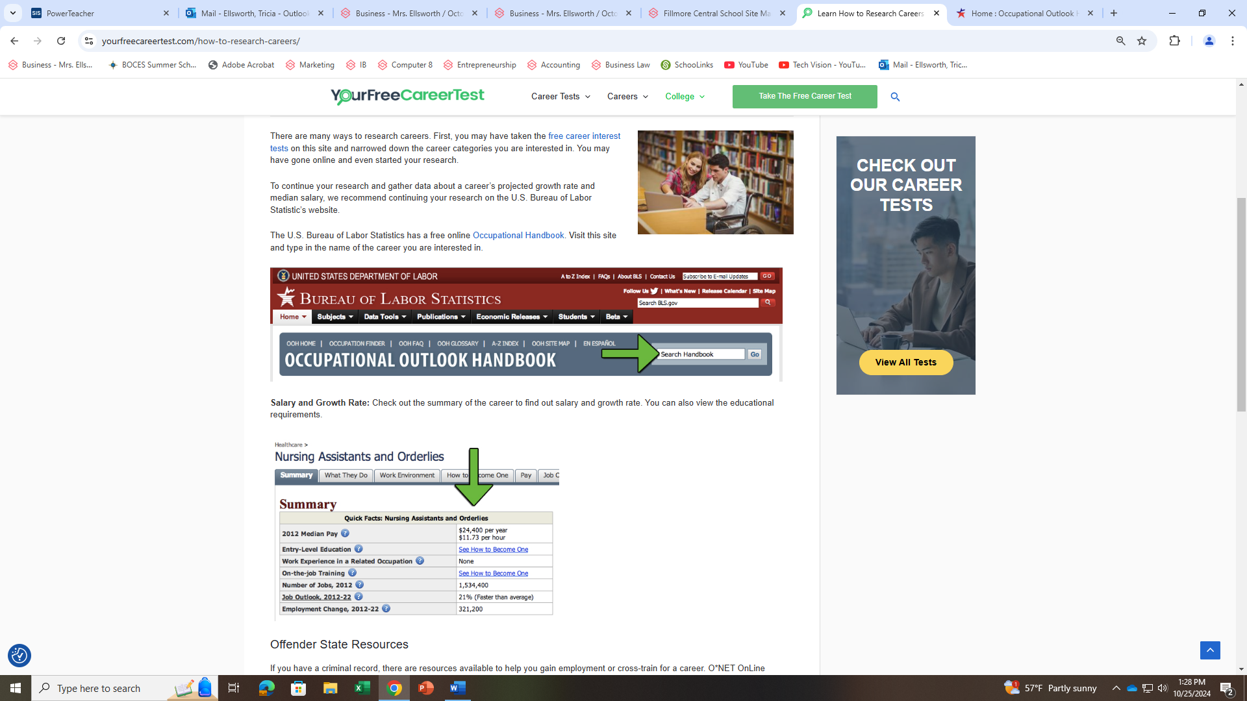
Researching Careers
Part 1
Choose 4 careers from the many you highlighted from Your Free Career Test job lists.
Write them here
- ____________________________________ 3. _________________________________________

- ____________________________________ 4. _________________________________________

Part 2
Now go on to the Occupational Outlook Handbook and search them all up.
Did you find them all? If not, tell me which ones you did not find.

