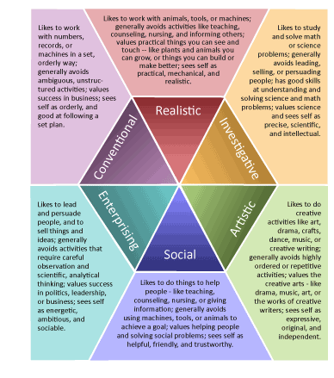Name ___________________________________