Creating, Using, and Sharing OneDrive Folders
Log into your account at portal.office.com:
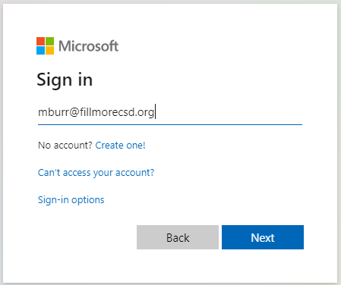
Click on the OneDrive icon:
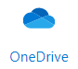
Click New, Folder:
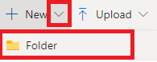
Name your folder and click Create:
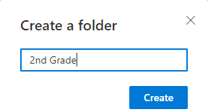
Click on your new folder:
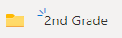
You should now have an area where you can put files, videos, etc.
Open the folder you want to share. At the top of the window, select Share: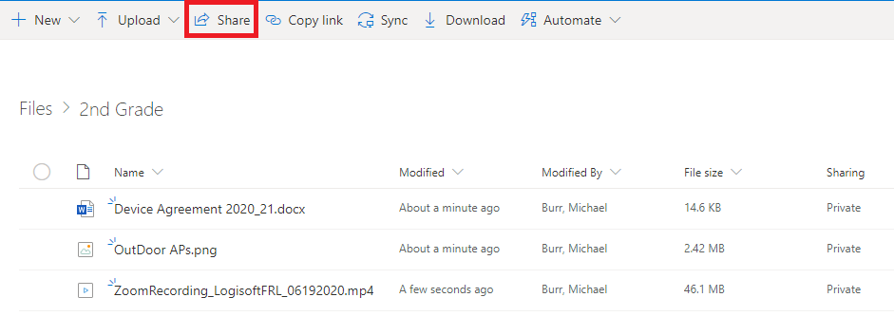
In most cases, you will only want your students to be able to view the files, so click the box that says Anyone with the link can edit
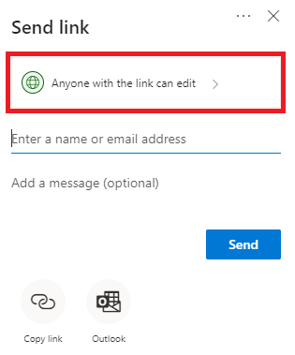
In the next window, uncheck the Allow editing and set any other settings you’d like, then click Apply

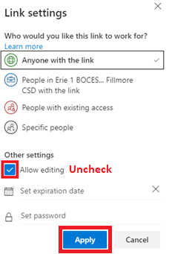

Back at the window, you have a few options for sending the link out. 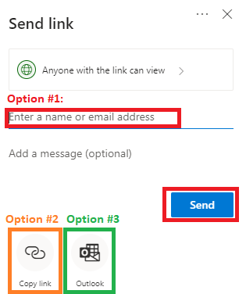
Option #1:
Enter email addresses of people you want to have the link, then click Send.
Option #2:
Click Copy Link, and you’ll be given the option to copy the link and use it wherever you’d like.
Option #3:
Select Outlook. A new window will open to your email, with a link already inserted in the email.

